**Steps to Create Request for New Centrify Zones**

**1.** Goto <https://jnjprod.service-now.com/iris> and click on “**IT Service Item Catalog**”

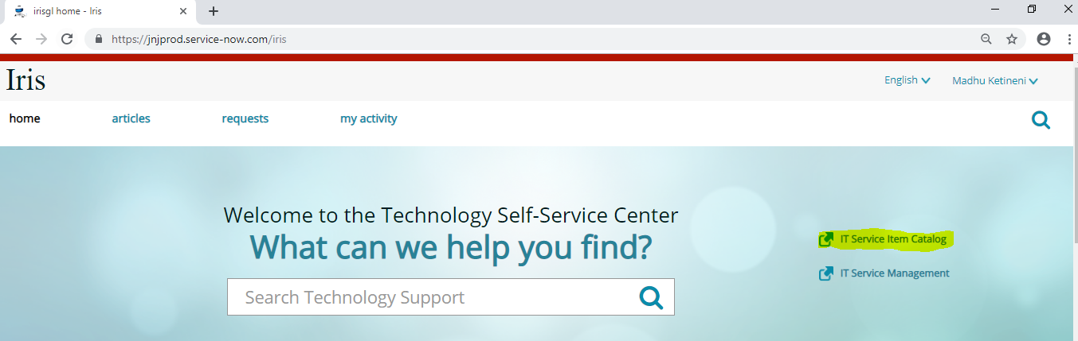

**2.** Select the tab “**Submit a request**” and click on “**Identity & access management”**

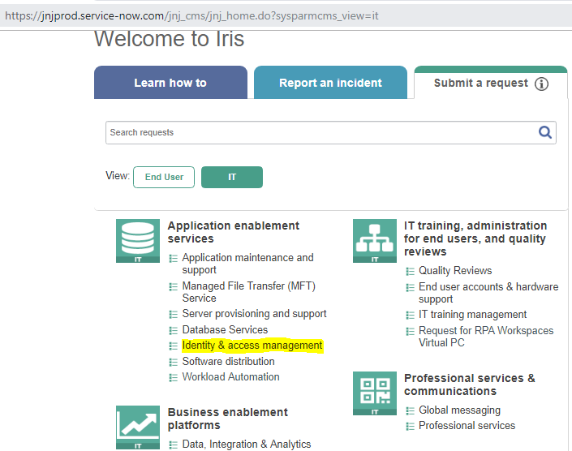

**3.** Click on “**Request for Directory service operations**”

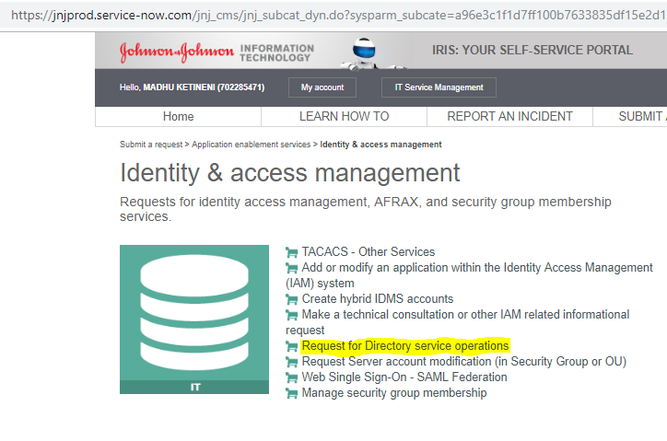

**4.** On the next screen “**Provide the address**” and select “**Other requests for directory service operations**” and in “**Describe Additional Details Associated with this Request**” enter the New Custom Zones to be created.

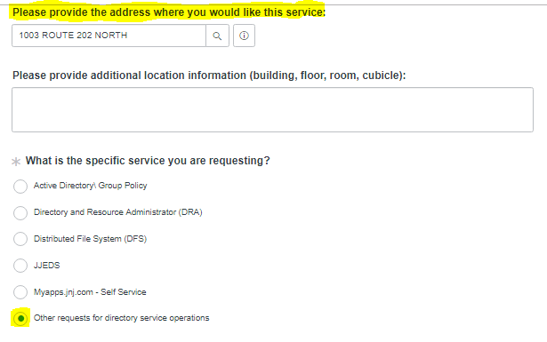

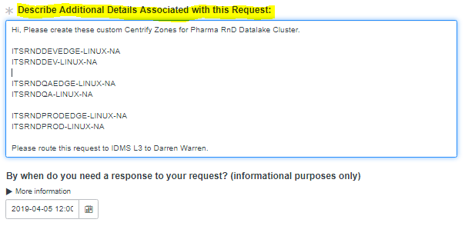

**5**. Click on **“Order Now”** on the top right side of the screen and your request will be submitted.

